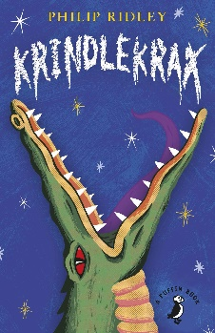
w/c 18th May 2020
Krindlekrax comprehension questions
You can record your answers in your exercise books, on paper or on the computer. If you would like them marked, you can email them to Y5@oulton.leeds.sch.uk

Chapter Five
1. When does Ruskin’s dad like to sit and talk to his model animals?
2. Why does Winston collect model animals?
3. Find and copy an example of alliteration from this chapter.
4. What does is mean by ‘distinctive smells’ on p.20?
5. Why do you think Winston’s dad was sacked from the zoo? Use evidence from previous chapters to support your answer.

Chapter Six
- Why is Ruskin’s mum ‘kneeling by the front door’?
- What is making the sewers particularly smelly?
- Why is Dr Flowers always sneezing?
- Dr Flowers’ surname is ironic. What does this mean?
- What does it mean when the author writes ‘sniffing to ward off yet another sneeze’?
- When does Elvis commit some of his crimes? Use the text on p.23 to find the answer.
- What impression do other people on the street have of Elvis? Why? Use evidence from the text to support your answer.

Chapter Seven
- What is Mr Lace’s favourite pastime?
- After reading p.24, what is your impression of Mr Lace? Use evidence from the text to support your answer.
- Why do you think Ruskin struggles to make friends?
- How does the class make Mr Lace ‘cr[y] in frustration’?
- What is the meaning of the word ‘insignificant’?
- Why do the class laugh when Ruskin is stood next to the dragon? Use evidence from the text to support your answer.
- Why do you think that Mr Lace allows the rest of the class to laugh at Ruskin?
- How do you think Ruskin feels after he’s told to sit down? Why?
- Do you still think Ruskin will get to play a part in the play?

Chapter Eight
- Do you think Elvis will learn all his lines? Give reasons for your answer.
- Why does Mr Lace get so emotional when anyone mentions Shakespeare?
- Why does Elvis continue to mention Shakespeare?
- What is a ‘Bard’?
- What do you think the class’ impression of Corky is? Use evidence from the text to support your answer.
- ‘Corky glanced at the class. He noticed Ruskin and gave him a wink.’ What does this tell you about Corky and Ruskin’s relationship?
- Who is your favourite character in the book so far? Why?
- What do you think will happen in the next chapter?

