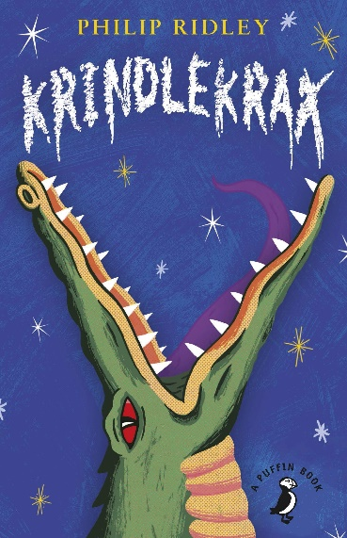
w/c 8th June 2020
Krindlekrax comprehension questions
You can record your answers in your exercise books, on paper or on the computer. If you would like them marked, you can email them to Y5@oulton.leeds.sch.uk

Chapter 13
- What is unique about the way Corky eats his biscuits?
- ‘the pavements weren’t cracked for one thing. And the brickwork wasn’t dark and the road didn’t have any bumps and holes in.’ What impression do you get of Krindlekrax from this description?
- What did Corky do before he was a caretaker?
- Did Corky enjoy working in the sewers? How do you know? Use evidence from the text to support your answer.
- How many examples of similes can you find on page 57?
- How does the author create suspense at the end of this chapter? Use evidence from the text to support your answer.

Chapter 14
- Why is Ruskin shivering at the start of this chapter?
- Corky took a deep breath. What does this tell you about what is coming next?
- My torch beam cut through the darkness. Why does the author choose this verb to describe how his torchlight shone?
- What expanded noun phrases does the author use to describe the crocodile?
- What does the word enticing mean?
- How does Corky end up with a limp?
- What is your impression of how Ruskin feels about Corky’s story about the crocodile in the sewers? Use evidence from the text to support your answer.
Chapter 15
- How did Corky know that the crocodile was still in the sewers?
- What had happened to the crocodile over the years?
- Why did the crocodile have a particular interest in Corky?
- How did Krindlekrax get its name?
- How was Corky feeling after his second encounter with Krindlekrax? Use evidence from the text to support your answer.

Chapter 16
- Where and when does Krindlekrax emerge according to Corky?
- Why do you think that Corky keeps the tin helmet?
- Why is Ruskin upset in this chapter?
- ‘None of us is safe forever,’ Corky said. ‘We can only be safe for little whiles at a time.’ Why does the author use non-standard grammar here for when Corky is speaking?
- What do you think Corky’s golden medal is for? Give reasons for your answer.

Chapter 17
- What does the word ‘contentedly’ mean?
- On page 71, why does the author use lots of short sentences?
- How does the author create an image of the sewers in your mind? Use evidence from the text to support your answer.
- What did Ruskin have for his tea that evening?
- Why does Ruskin not like having newspaper in the windows?
- What is a motto?
- What is the purpose of the news report about the weather? Could it be giving us a clue as to what might come next in the story? If so what?
- Where does Wendy put all their leftover toast?
- What do you think will happen in the next chapter?

