Dear Parents, Carers, Staff and Governors,

I can’t believe my first full term as Headteacher at Oulton is almost over. It has flown by! I have thoroughly enjoyed meeting you all and look forward to continue working together over the coming weeks, months and years. I am very positive about the future of our fabulous school and community and I know there are great things in store for our children.

We, like you I am sure, have been really enjoying the improving weather and all the signs of spring around us. Hopefully we have a lot of lovely weather ahead of us and we can finally put the winter hats, gloves and scarves away for a bit! The children are looking forward to making use of our lovely school grounds even more over the next term.

It was wonderful to open our doors to you all during the week commencing 17th March for Parent Teacher consultations and to welcome many of you to our ‘Learn with us’ sessions. It was encouraging to see so many people attend and I know all the staff thoroughly enjoyed celebrating your children and the progress they have made this year. Positive home-school relationships are the key to success. We do always welcome your feedback, so if you would like to complete our Parent view survey then please do so by Sunday 6th April at 6pm using the link below.

https://forms.office.com/e/d5dKB0g88d

From Tuesday 22nd April, the gate which the children in Years 5 and 6 come through will no longer be in use during the school day between 8:30am and 3:30pm. Following a visit from the Local Authority health and safety team it was deemed that the children walking across the road and the carpark was too dangerous during the school day due to the movement of vehicles. Children and parents/ carers can access the school via the nursery gates at the front of school or the bottom playground gate and walk round to class and enter school in the way they do now.

I wish you all a restful Easter break and hope the children take this time to re-charge their batteries ready for a jam-packed summer term, full of exciting learning opportunities.

Thank you for all your continued support; it is invaluable to us.

Kind regards,

Mr McAlinden

School Grid

We are excited to announce we have moved our school dinner ordering and payments to a new system called School Grid. This has replaced the School Money system. This is a positive step forward and is designed to make transactions easier. Please take the time to sit with your child to place your school dinner orders. If you have any questions or queries don’t hesitate to contact the school office.

Click here to login: https://app.schoolgrid.co.uk/login.aspx?ReturnUrl=%2F

Celebrating behaviour

We are very proud of the way our children behave and conduct themselves around school and it is important to them, and us, that this is acknowledged and celebrated. This half term the marble jar has been filled three times, which is a fabulous accomplishment. The first time it was filled, the reward was a silent disco. This takes place in the hall on Friday 4th April and we all look forward to seeing children bring their best dance moves to enjoy this treat!
The second time the jar was filled, the children enjoyed a bingo session in their classes.
The third time the jar was filled, the spinning reward wheel landed on ‘woodland time’ and children have been enjoying their slot across the course of this week, exploring and soaking up our natural environment.

We are all proud of the efforts each and every pupil has made to fill these jars.

POPS update

We would like to extend a huge thank you to POPS for funding the recent ‘Oultimate Respect’ Ice Cream reward – the children were very grateful to POPS for providing this well-deserved sweet treat. More thank you to the POPS volunteers for their immense efforts in producing over 200 Mother’s Day gifts. We do hope all of the mums were spoilt and had a fabulous day.

The next exciting POPS event is the Krispy Kreme Doughnut Sale – thank you for getting your
pre-orders in today. Doughnuts will be sent home on Friday 25th April. Enjoy!

Diary dates
Key dates for your diary

4th April – KS2 Spring Sing (Time to be confirmed)
5th – 22nd April - school closed for Easter holidays (We return to school on Tuesday 22nd April)

23rd April - class photographs. Please make sure children attend with their best smiles on this day. This year there will be a Year 6 group photograph taken for our 2025 leavers to purchase.
25th April – Krispy Kreme Doughnut delivery
5th May – Bank Holiday Monday
12th May – Year 6 SATs week

Staffing updates

Our Oulton staff team continues to grow as this term we have welcomed Miss Standring to our Reception team as a Teaching Assistant. After Easter, we also warmly welcome some more new faces: Mr Coleman join Oulton as a Higher Level Teaching Assistant and he will provide cover for staff absences and planning time for teachers. Miss Broadley also joins our Reception team as a Teaching Assistant along with Mrs Langridge and Mrs Giddens who join us in a lunchtime role. Richard Wilton completes what has been a busy period of recruitment for school as he joins our cleaning team. We know you will all make these new staff members feel welcome.

From September 2025, we will also welcome some of our existing fabulous support staff into our Angelfish staff team on a permanent basis. Mr Townend, Mr Braid and Miss Shepherd have all secured permanent roles at Oulton Primary. Congratulations to these staff – we are proud to have you continue your Oulton journey!

Comic Relief 2025

It was a real delight to see children coming to school dressed in their inside out and back to front outfits for Comic Relief. The sound of laughter rang out around the school as children enjoyed entertaining each other with their very best jokes. We were very keen to support this fabulous national charity to raise money for children facing poverty in the UK and around the world. We thank you all for your kind donations.

Safeguarding



Reception 2025 offer day

It’s hard to believe it but we are about to enter Reception admission time and we look forward to welcoming our next intake of Oulton pupils into our school community. This year places are allocated during the school Easter break, on the 16th April.

We will be hosting a welcome meeting for parents and carers of children due to start Reception in September 2025 on Wednesday 2nd July at 5.00pm. The meeting will be held in the school hall, and it aims to give our new parents all the key information they need about life at Oulton. Our aim is to make starting school an easy and happy process for both the children and their adults. There is lots of information that we will share and we will ensure that this is done as effectively as possible.

We want to be able to get to know our new children and are busy planning further transition opportunities. On Thursday 10th and Friday 11th July, we will be inviting the children to a Stay and Play visit in Reception.
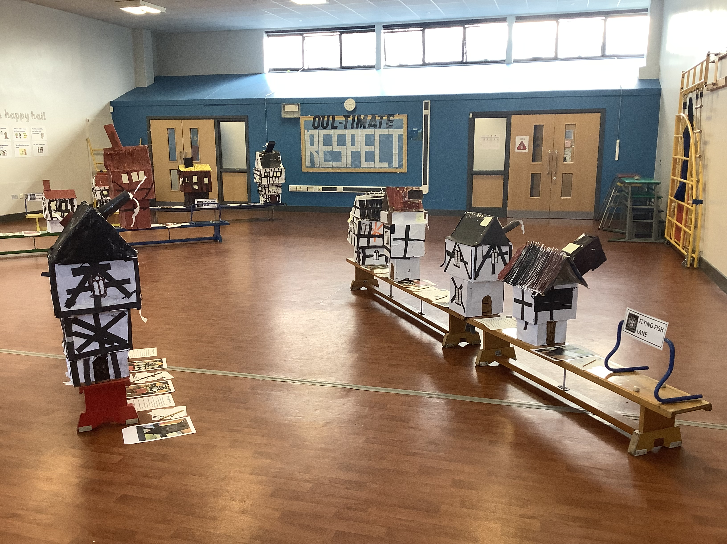
Trips and visitors

We continue to enhance our children’s learning with lots of additional and enriching opportunities at Oulton. Here are just a few of the exciting things our children have enjoyed this term and are looking forward to for next term.
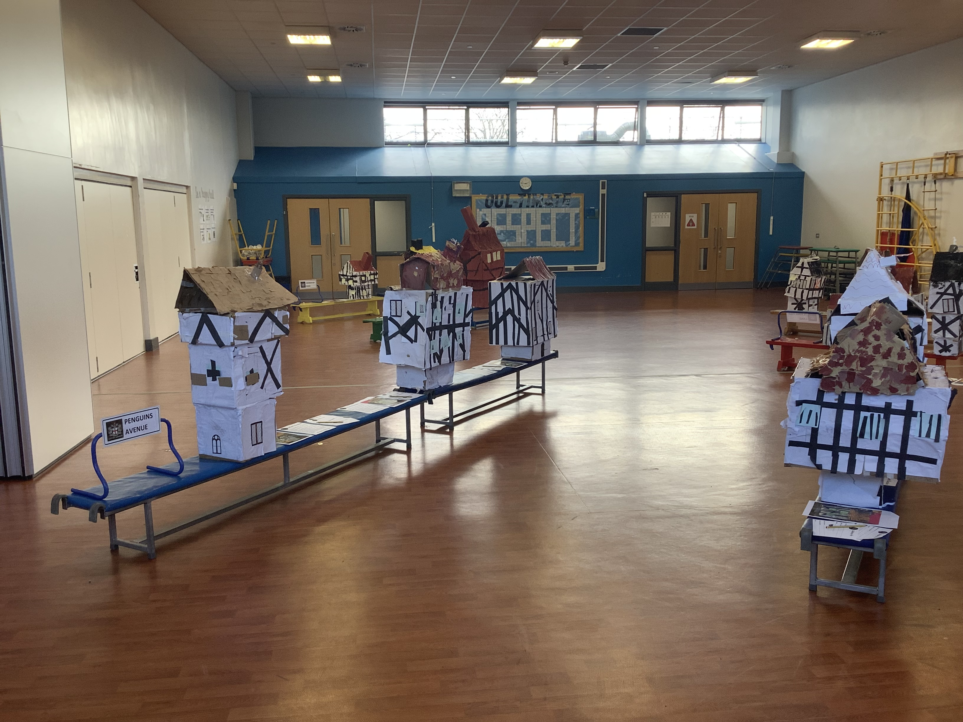
Year 1 and 2 worked brilliantly in teams to create some impressive tudor houses. This project culminated in a silent auction in the hall where we received some very generous bids from parents and carers, hoping to buy the houses! Thank you to everybody who made a bid – the money raised will go towards new resources for our KS1 children.

Year 3 and 4 enjoyed bringing their history topic to life when they hosted their Roman visitor. They enjoyed this hands on and practical way to open a window to the past.

This week Nursery welcome a visit from Riggmoor Travelling Farm. This means some cute and fluffy friends will visit Oulton. The children are very excited to come face to face with some of the animals they have been learning about as part of their topic.

Year 6 are very excited about their upcoming visit to Eden Camp as part of their history topic to learn outside of the classroom. Eden Camp is a former prisoner of war camp dating back to WWII and the children will be able to bring their learning to life on this visit. In class the children have been studying the book Rose Blanche which has also helped them develop empathy for what it would have been like to live through this difficult period in our past.

Reception are also looking forward to enhancing their learning about their summer term topic Madagascar with their forthcoming trip to Askham Bryan Wildlife and Conservation Park in York, on Thursday 8th May. They will be taking part in a bespoke workshop to learn all about lemurs. They will also enjoy a talk from one of the experts before spending time seeing the lemurs in their enclosures. They will also have fun exploring the rest of the wildlife park and see the other amazing animals and nature trails. We can’t wait to see photos of the lemurs.

This term. KS1 and KS2 had an assembly about the importance of being in school every day, on time. Miss Cooper and Miss Birch then challenged the children to design posters to inform people about this and ran a competition to celebrate the best ones. There were lots of amazing entries and the winning posters will be displayed around school. Here are a few of the winners:

